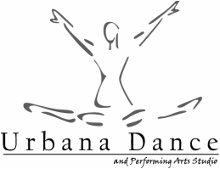
Karly Parker | Pre-Dance, Ballet, Jazz Instructor
Karly's love for dance started at an early age as a member of Dance Electric Performance Troupe and the Kansas City Dance Theatre Company where she was able to showcase her talent at Disney World as well as on The Big Red Boat Cruise Line. She studied dance at Kansas State University where she was a member of The Classy Cat Dance Team. After college, Karly also built a name for herself through choreography. She was able to collaborate and choreograph for various collegiate level dance teams in the United States. Karly married and moved to Camp Lejeune, NC where her husband was stationed in the Marine Corps. She started Miss Karly's School of Dance, where she built a dance program for military children. The program grew from 5 students to 300 students in just 3 short years. Karly then took a short break to become a mom and relocate back to Kansas after her husband's enlistment was finished. She then became a Regional Manager of a Ballet Company, A Fairytale Ballet, in Overland Park and Prairie Village, KS. Karly's dance techniques and styles have been featured in Dance Teacher Magazine and Dance Spirit Magazine. In 2010 she opened her own studio, Top Performance Inc. Karly created and directed a Preschool Dance Program at Child Development Centers all over the Kansas City area. Judging at various dance competitions across the country is also a part of Karly's success. She currently judges for BravO! National Dance and Talent Competition and In10sity Dance Competition. Karly hopes to pass on her love for dance to her students and give them access to the same opportunities she has as a child, to further build their dance experience and education.

